CHADLINGTON CE PRIMARY SCHOOL RE CURRICULUM & ASSESSMENT OVERVIEW

Intent:

The purpose of this RE Curriculum is to give pupils from EYFS through to Year 6 a coherent picture of Christian worldviews and a range of other worldviews in line with the Oxfordshire ‘Challenging RE’ Agreed Syllabus.

The aim is to develop curiosity in pupils, equipping them for future learning and enabling them to make sense of the complex world of religious and non-religious worldviews. The school aims to engage pupils of any religious faith or none and of all academic ability and social backgrounds. It does not seek to impose beliefs upon pupils, nor to compromise their own beliefs but rather to deepen their self-understanding and their understanding of others.

Pupils explore a range of concepts driven by three core strands: Beliefs & Questions, Community & Identity and Reality & Truth. These strands create connections between substantive and disciplinary knowledge and provide opportunities for the development of personal knowledge. Beliefs & Questions focuses on theology, looking at the core beliefs and diverse interpretations of text, symbols and teachings of the chosen religions and worldviews. Community & Identity examines practices and expressions of religious and non-religious beliefs. Reality & Truth focuses on philosophy and ethics, looking at how people decide what is true, drawing on different worldviews.

Pupils will be given the opportunity to explore the wider concept of what a worldview is and how people reach these ideas. This contributes positively to the spiritual, moral, social and cultural development of pupils, encouraging them to assimilate ideas and beliefs to begin to develop their own worldview, whilst gaining understanding and tolerance of the beliefs of others. Through the process of enquiry and reflection, we aim to encourage individuals to recognise the worth of their unique views and to develop as courageous advocates, equipped with the knowledge, skills and understanding that they need to ‘let their light shine”, making the world a brighter place for themselves and others.

Implementation:

The scheme of work is based on the ODBE scheme of work for schools, 2023. It has been adapted, however, to meet the learning needs of the school community and to ensure that meaningful links are made with other key disciplines in the school’s bespoke curriculum. Objectives in the school’s scheme of learning are detailed in the Interactive Learning Diary (https://www.interactivelearningdiary.co.uk/portal/), which also supports formative assessment of pupils’ learning. The ODBE ‘Building Blocks’ provide broader brushstrokes informing summative assessment, ensuring pupil progress and breadth of coverage across the school. Their use helps to identify prior learning and inform future learning, so that planning can be adapted appropriately to meet individual needs. Depth is developed through the teaching of the three core strands and breadth is provided through the study of different worldviews. Learning should follow the process set out in ‘Challenging RE” (see diagram on p.2).

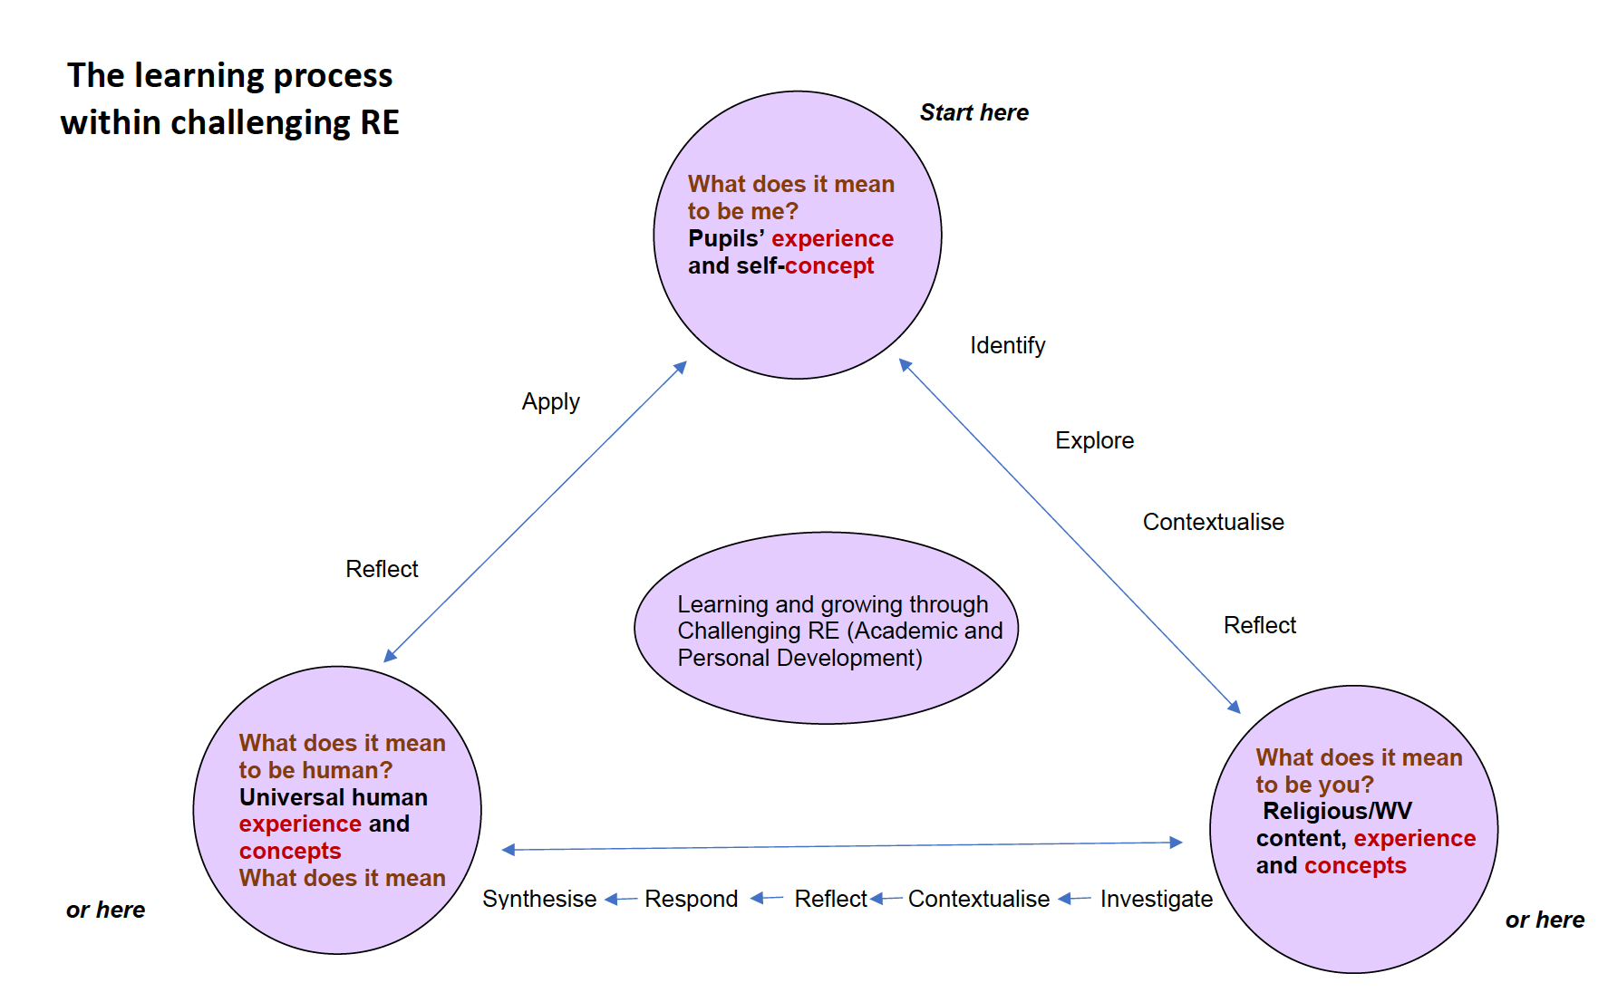

Impact:

Pupils will know more and be able to give an age-appropriate, coherent account of Christianity and the other worldviews covered. They will be able to ask questions, use a range of sources and skills to explore the traditions taught and have developed curiosity about how and why people think and act. They will know that there is more to learn about religious and non-religious worldviews and have developed the skills to research further. Pupils will understand that there are different ways of interpreting texts, and that different people reach different conclusions about what is true, good, right, and wrong. Outcomes, progression, and improvement information will be monitored by the Collaborative Development Team in line with the annual MER cycle so that the scheme and/or learning objectives can be adapted to meet individual needs and school expectations.

Coverage of Worldviews:

At KS1, pupils will explore:
- Christianity in depth
- One other Abrahamic religion in depth (Judaism),
- With reference to one Dharmic tradition (Sikhism) and non-religious perspectives

At LKS2, pupils will explore:
- Christianity in depth
- One other Abrahamic religion in depth (Islam),
- One Dharmic tradition in depth (Hinduism),
- With reference to other religions and perspectives, as appropriate.

At UKS2, pupils will explore:
- Christianity in depth
- One other Abrahamic religion in depth (Islam)
- One Dharmic tradition in depth (Hinduism)
- Humanism
- With reference to other religious traditions, as appropriate

Year 1: Once Upon a Time

 | FS/KS1 | LKS2 | UKS2
1A - We are storytellers | Christian Worldviews:  Beliefs and questions  How do stories help Christians find out what God is like? | Christian Worldviews:  Beliefs and questions  How are different people inspired by the stories Jesus told? | Christian Worldviews:  Beliefs and questions  How far is belief in the resurrection important to Christians today?  Visit: Shrine of St. Frideswide, Christ Church Cathedral, Oxford
1B - We are historians | Christian Worldviews:  Community & Identity  How does belonging to a religion or group affect people’s lives?  Visit: St. Nicholas’ Church, Chadlington | Christian Worldviews:  Community & Identity  How and why has Christian practice changed over time? | Christian Worldviews:  Community & Identity  How and why do Christians try to make the world a better place?  Visit: The Foundling Hospital & Charles Dickens Museum Visit, Christmas Explorers
1C - We are thinkers | Religious & Non-Religious Worldviews:  Reality & Truth  How do people know how to behave? | Religious & Non-Religious Worldviews:  Reality & Truth  Does it matter if a story is true or not? | Religious & Non-Religious Worldviews:  Reality & Truth  What does it mean to live a good life?
1D - We are textile designers | Religious & Non-Religious Worldviews:  Community & Identity  How and why is Shabbat important to some Jewish people in Britain? | Religious & Non-Religious Worldviews:  Community & Identity  What is Eid al-Adha and how is it celebrated? | Religious & Non-Religious Worldviews:  Community & Identity  How does faith unite a community?
1E - We are filmmakers | Christian Worldviews:  Reality & Truth  What questions do the parables of Jesus and/or stories in the Bible make us want to ask? | Christian Worldviews:  Reality & Truth  Does prayer make a difference and how do Christians know?  Visit: Father Mark | Christian Worldviews:  Reality & Truth  Does wisdom look the same for everyone?
1F - We are imagineers | Religious & Non-Religious Worldviews:  Beliefs & Questions  What do Jewish people believe about God as ‘creator’ and how does this compare to Christian beliefs? | Religious & Non-Religious Worldviews:  Beliefs & Questions  How How do Hindus understand God (Brahman)? | Religious & Non-Religious Worldviews:  Beliefs & Questions  What is the significance of Karma and Moksha for a Hindu?

Year 2: A Sense of Place

 | KS1 | LKS2 | UKS2
1A - We are palaeontologists | Christian Worldviews:  Reality & Truth  How do Christians decide what is right?  Visit: The Oxfordshire Museum: Dinosaurs | Christian Worldviews:  Reality & Truth  Does art help with understanding stories?  Visit: The National Gallery | Christian Worldviews:  Reality & Truth  How do people make valid judgements about how and why the world is as it is?  Visit: The Natural History Museum
1B - We are explorers | Religious & Non-Religious Worldviews:  Community & Identity  What does the Torah mean for Jewish people? | Religious & Non-Religious Worldviews:  Community & Identity  What might a Hindu gain from a pilgrimage to India? | Religious & Non-Religious Worldviews:  Community & Identity  What might a Muslim gain from a pilgrimage to Mecca?
1C - We are engineers | Religious & Non-Religious Worldviews:  Beliefs & Questions  In what way is the synagogue important to Jewish people?  Visit: OJC Synagogue | Religious & Non-Religious Worldviews:  Beliefs & Questions  What makes a mosque a special place of worship for Muslims?  Visit: Bristol Central Mosque | Religious & Non-Religious Worldviews:  Beliefs & Questions  What makes a Mandir a special place of worship for Hindus?  Visit: Hindu Temple (https://hinduismre.co.uk/)
1D - We are artists | Christian Worldviews:  Beliefs & Questions  How does art tell the story of Jesus? | Christian Worldviews:  Beliefs & Questions  How did Christian beliefs affect Renaissance Art? | Christian Worldviews:  Beliefs & Questions  How can we share our beliefs through art?
1E - We are architects | Religious & Non-Religious Worldviews:  Reality & Truth  Why do some people go to a place of worship? (Sikh temple) | Religious & Non-Religious Worldviews:  Reality & Truth  How and why do some people argue that some places can be spiritual? | Religious & Non-Religious Worldviews:  Reality & Truth  How does a worldview help people decide what is important?
1F - We are musicians | Christian Worldviews:  Community & Identity  Why do many Christians meet together regularly and what do they do? | Christian Worldviews:  Community & Identity  How does the worldwide Christian family celebrate, worship and mark key events? | Christian Worldviews:  Community & Identity  How do rites of passage shape the lives of different Christians?



